This Lesson is copyrighted to the Tut Writer, © esamu2021 This Lesson may not be forwarded, shared or otherwise placed on any Web Site without written permission from ©Esamu.
This tutorial was create in PSP 9 Version, but can also made in the other Versions.
Drag the green circle to mark your place in the tutorial
Supplies
telitaj.pspimage
girl.png
hid.pspimage
worldart.peace.png
peace.fls
Pligins used
MuRa's Filter Mei ster – Cloud
Xero-Porcelan
AFS Import-sqborder2
Mehdi-Absolute color
Preparation
Double click the. fls files to save to your Alien Skin Eye Candy 5 –Impack-Perspectve Shadow Presets
Materials Palette
Foreground #ffffff
Background #c4ccb5
Step 1
Open New File 800x 600 white
Layers - Promote Background Layer
Foreground #ffffff, Background #c4ccb5
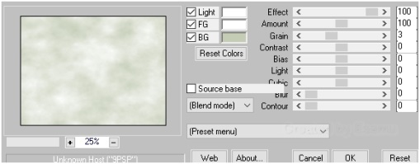
Step 2
Maximize telitaj.pspimage
Windows-Duplicate, close the original.
Edit-Copy
Edit -Paste as New with the Move Tool, move to the top of to the right Layer
Layers Duplicate
Image-Mirror
This what you should have
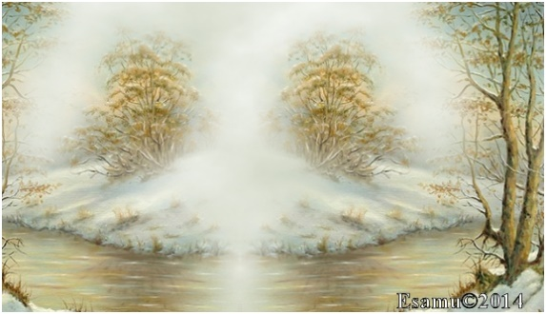
Step 3
Close the Raster 1
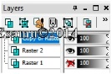
Copy of Raster1 and Raster2 Merge down
Layers-Prperties- Overlay
Effects-Edge Effects-Enhance More
Open Raster1
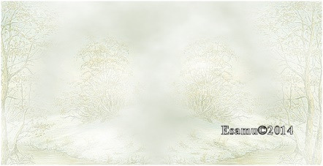
Open the hid.pspimage
Edit -Copy- Edit -Paste as New Layer
Layers-Properties-Opacity 44
Effects-Plugins Flaming Pear-Flood
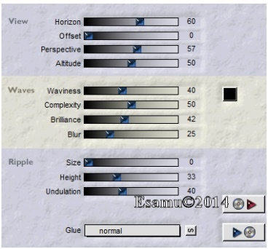

Open the peace.png image
Edit -Copy- Edit -Paste as New Layer
Effcts-Image -Image Effects-Offset
Horizontal offset-10 Vertical offset 100
Image-Resize56% All Layers not checked
Activate Raster3
Layers-Arrange-Bring to Top
Step 4
Open the girl.png image
Edit -Copy-Edit Paste as New Layer

With the Move Tool move a little left up, as you see on my image.
Effects-Plugins-Alien Skin Eye Candy 5.Impack-Perspectve Shadow…fls peace
Open the girl02.png image
Edit -Copy-Edit Paste as New Layer
With the Move Tool move a little left down to the right side, as you see on my image.
Effects-Plugins-Alien Skin Eye Candy 5.Impack-Perspectve Shadow…fls peace same settings
Layers- Merge Visible
Layers New Rater Layer
Flood Fill Tool-flood fill with background color
Step 5
Effects-Plugins- AFS Import-sqborder2
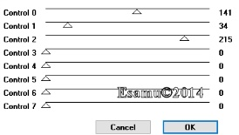
Layers Arrange -Move Down
Image –Resize 85 % All Layers not checked
Effects-3D Effects-Drop Shadow
H-V 2 Opacity 100,Blur 5 Color White
Repeat Drop Shadow H-V-2

Close the Raster1
Aktivate the Merged Layer
Effects-Plugins-Xero-Porcelan

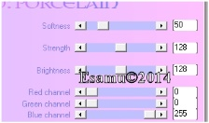
50.128,128,0,0,255
Open Raster1 Layer
Layers Merge All (Flatten)
Image –Add Borders
Add Borders 2pix White
Add Borders 2 pix #c4ccb5
Selections-Select All
Add Borders 20 pix #c4ccb5
Selections-Invert
Effects-Plugins- AFS Import-sqborder2
Same settings
Selections-Invert
Effects-Drop Shadow , same settings
Select None
Open the worldart.png image
Edit –Copy-Paste as New Layer
Move down
Effects-Drop Shadow
H-V—2 Color Black
Layers-New Layer
Add your Watermark and credits
Layers Merge All (Flatten)
File-Export –JPEG Optimizer
Compression value 20
Thank you
